**CP5046 ICT PROJECT 1 - ASSESSMENT TASK 2**

**PROJECT DOCUMENTATION**

**Team Number :** 5

**Group Member:** Xuan Hai Nguyen (12885170)

Gagandeep Singh (1312630)

Rajbir kaur gill (12864385)

 Anay Gharat (13131701)

**Lecturer Name:** Laura Antochi

Prototypes

Prototypes are demonstrated to justify the proposed Alpha-Release.

1. Home Page: create button register in home page and link to registration page.



1. Registration Pages

After the User register is successful, the information of the user will be stored in the database and accept user to login automatically. the page also presents the link login, logout and show the message “welcome user”

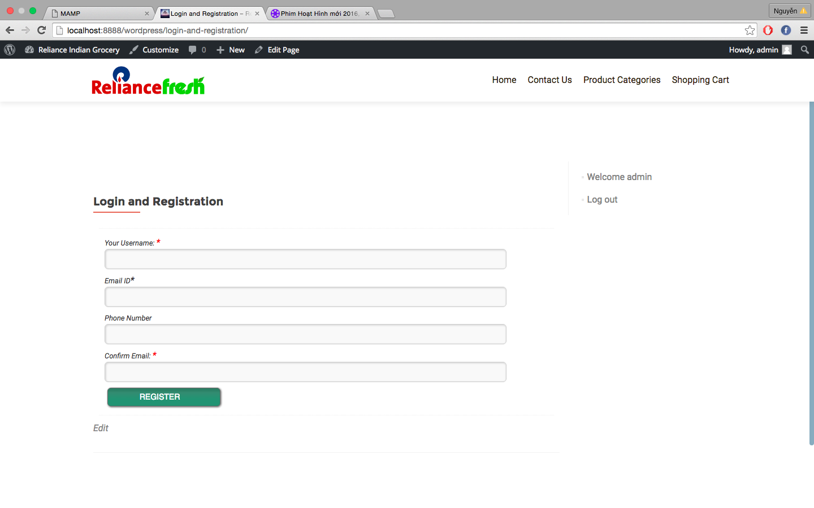

1. Contact Us page: use plugin contact 7 form

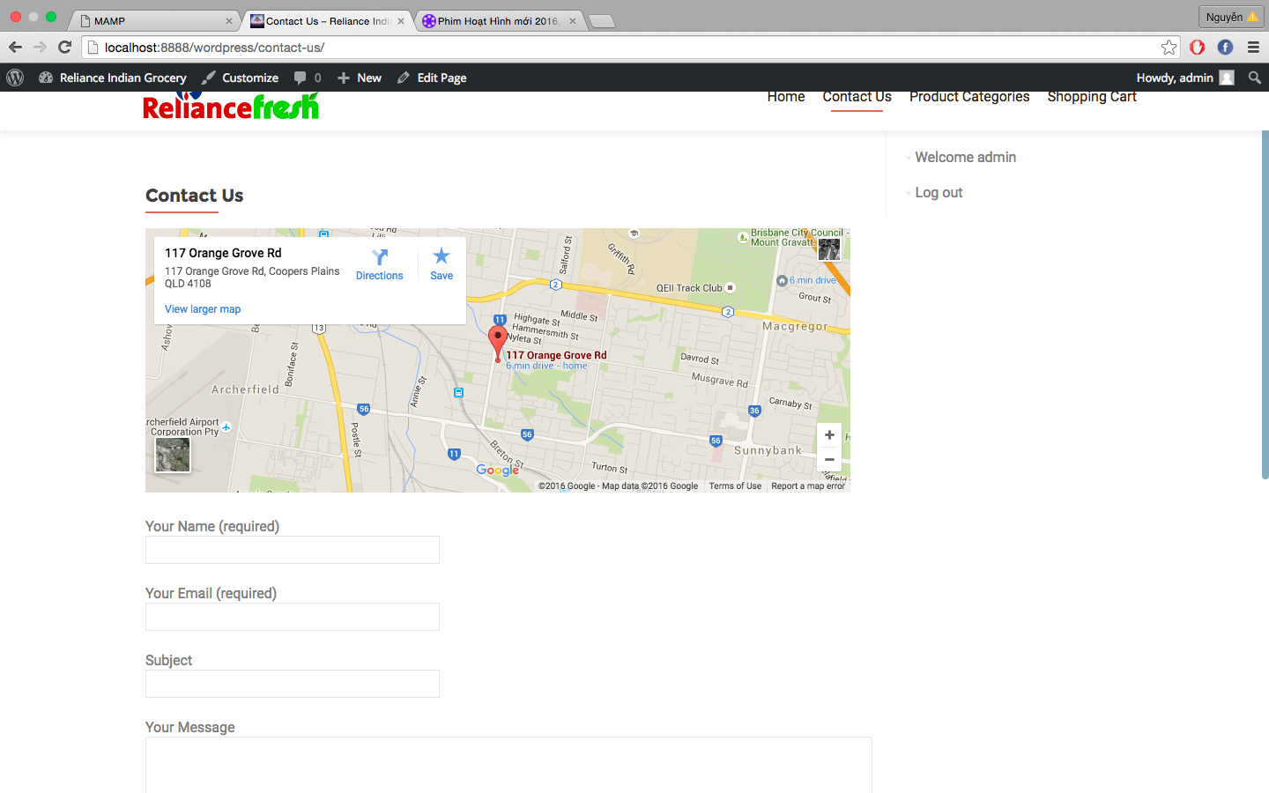

1. Product Categories page

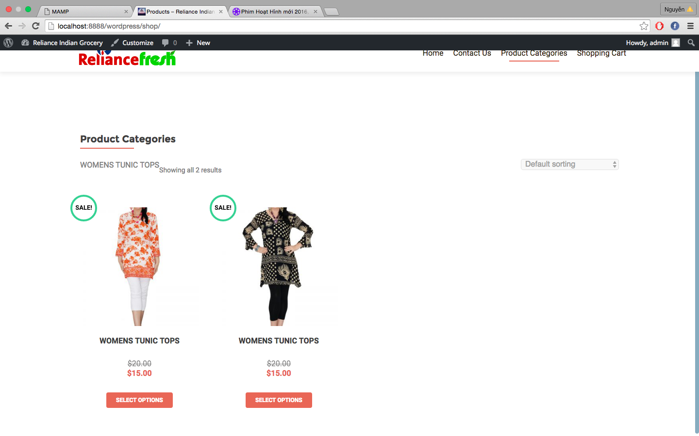

1. Deals and Offers page

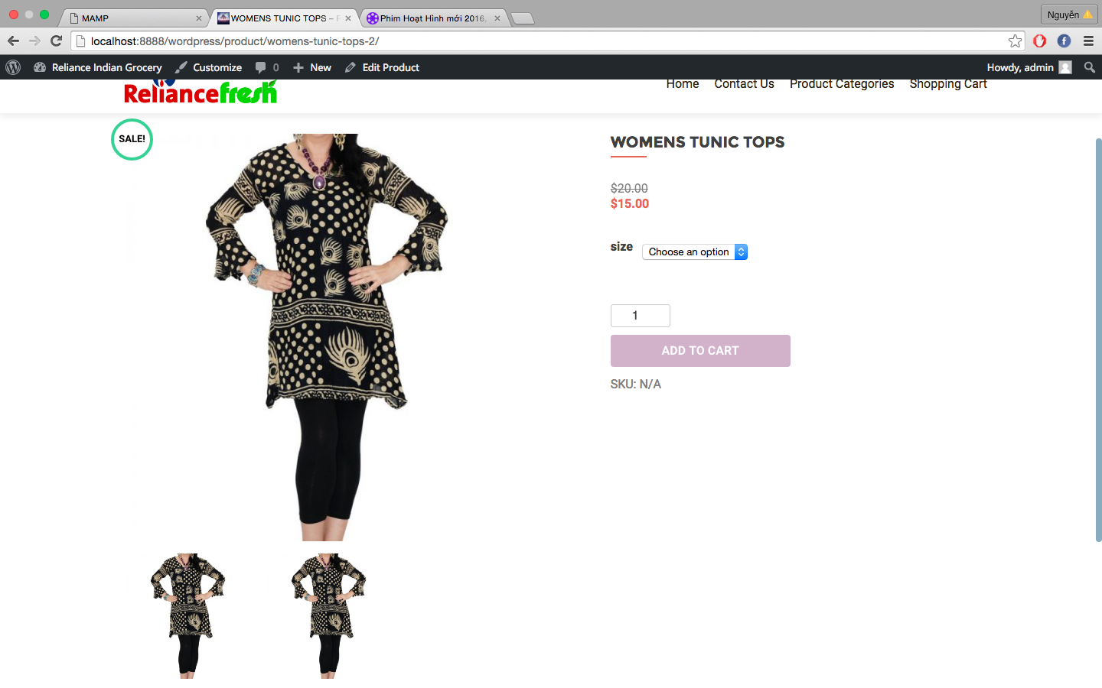

1. Shopping Cart page

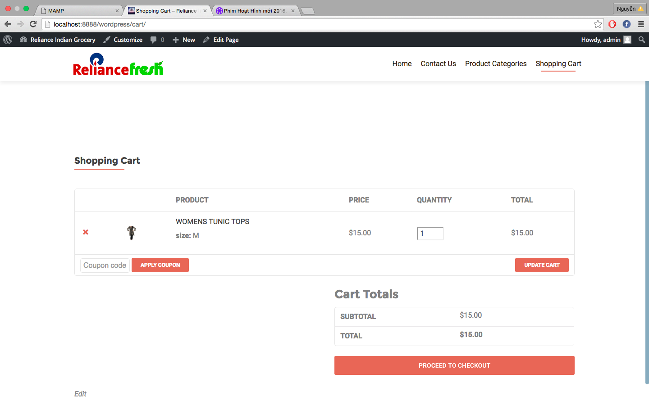

1. Check Out page

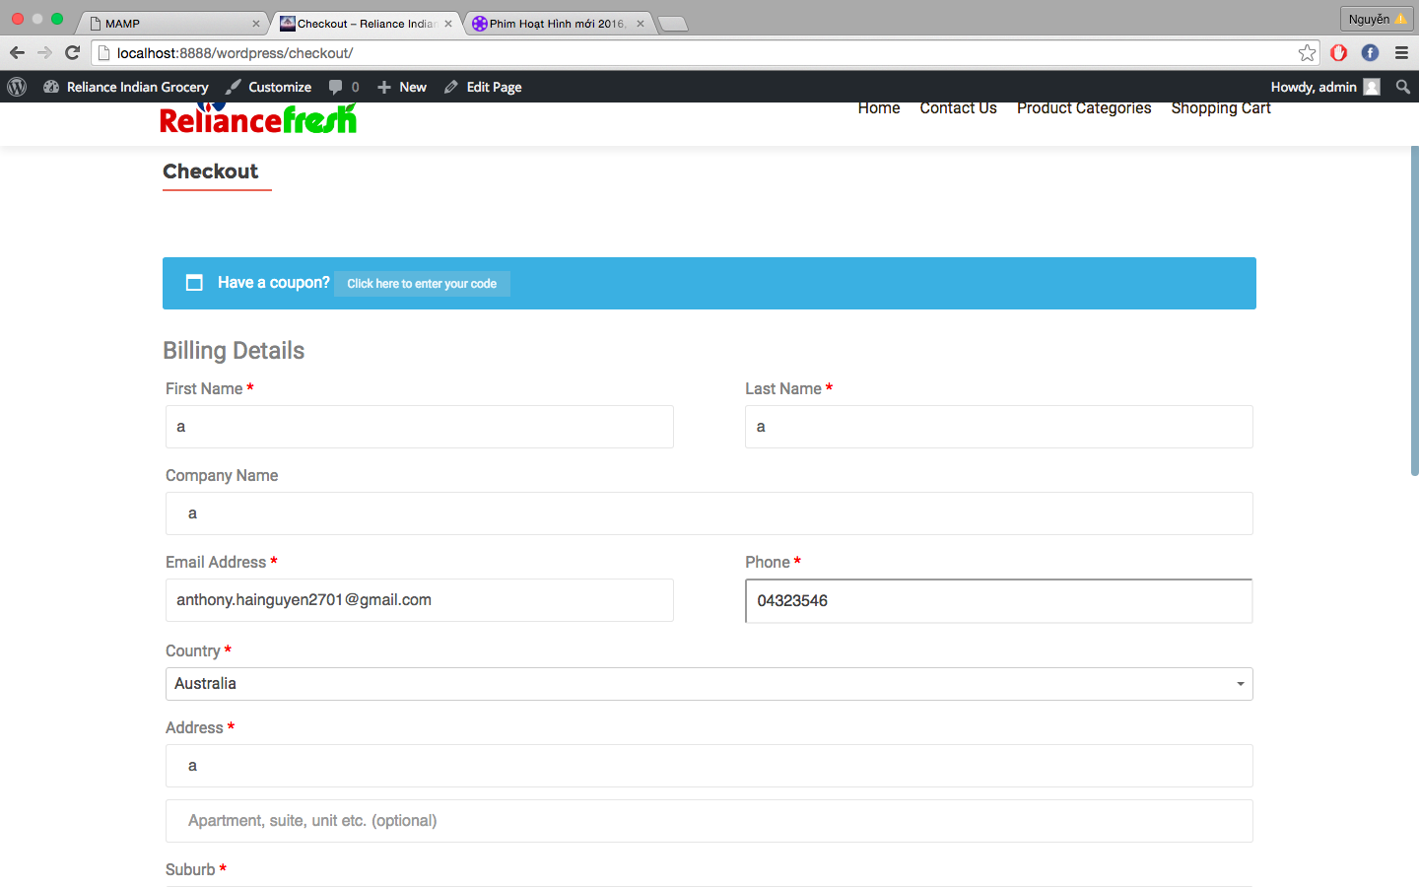

1. Payment pages

